**Project Design Phase-II**

**Data Flow Diagram & User Stories**

| Date | 25 March 2025 |
| --- | --- |
| Team ID | **SWTID1744137899** |
| Project Name | Book-store Quasar Books |
| Maximum Marks | 4 Marks |

**Data Flow Diagrams:**

A Data Flow Diagram (DFD) is a traditional visual representation of the information flows within a system. A neat and clear DFD can depict the right amount of the system requirement graphically. It shows how data enters and leaves the system, what changes the information, and where data is stored.



* User registers/logs in → Authentication Process → verifies with MongoDB  
  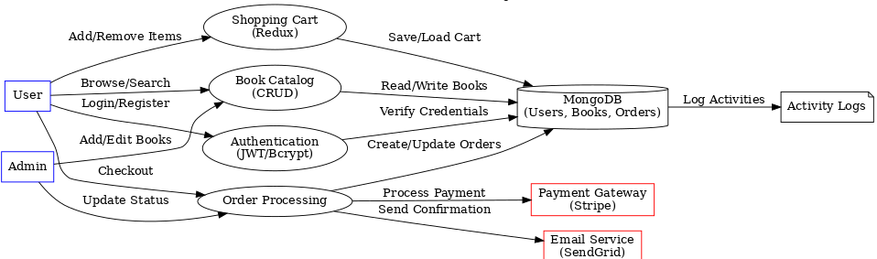
* User browses/searches books → Book Catalog ↔ MongoDB
* User adds/removes items → Shopping Cart ↔ MongoDB
* User checks out → Order Processing  
   → talks to Payment Gateway (Stripe)  
   → sends email via Email Service (SendGrid)  
   → updates MongoDB
* Admin manages books/orders → interacts with Book Catalog & Order   
  Processing
* All system actions log to Activity Log

**User Stories**

| **User Type** | **Functional Requirement (Epic)** | **User Story Number** | **User Story / Task** | **Acceptance Criteria** | **Priority** | **Release** |
| --- | --- | --- | --- | --- | --- | --- |
| Customer (Mobile user) | Registration | USN-1 | As a user, I can register for the application by entering my email, password, and confirming my password. | I can access my account/dashboard after registering. | High | Sprint-1 |
|  | Registration | USN-2 | As a user, I will receive a confirmation email once I have registered. | I receive the email and can confirm my registration. | High | Sprint-1 |
|  | Registration | USN-3 | As a user, I can register using Facebook login. | I can register and access the app via Facebook. | Low | Sprint-2 |
|  | Registration | USN-4 | As a user, I can register using Gmail login. | I can register and access the app via Google. | Medium | Sprint-1 |
|  | Login | USN-5 | As a user, I can log into the application by entering email & password. | Successful login redirects to dashboard. | High | Sprint-1 |
|  | Dashboard | USN-6 | As a user, I can view a personalized dashboard showing my recent orders, favorites, and recommendations. | Dashboard loads dynamically based on my data. | Medium | Sprint-2 |
|  | Book Browsing | USN-7 | As a user, I can browse books by genre. | I can click a genre and see related books. | High | Sprint-1 |
|  | Book Search | USN-8 | As a user, I can search for books by title or author. | Search results display matching books. | High | Sprint-1 |
|  | Cart | USN-9 | As a user, I can add books to my cart. | Books appear in my cart with updated quantity. | High | Sprint-1 |
|  | Cart | USN-10 | As a user, I can remove books from my cart. | Book gets removed instantly from the cart view. | High | Sprint-1 |
|  | Checkout | USN-11 | As a user, I can enter shipping details during checkout. | I can save and review address before order placement. | High | Sprint-2 |
|  | Checkout | USN-12 | As a user, I can complete payment via card or UPI. | Successful payment gives order confirmation. | High | Sprint-2 |
| Customer (Web user) | Login | USN-13 | As a web user, I can log in using the same credentials as the mobile app. | I am redirected to dashboard after login. | High | Sprint-1 |
|  | Book Management | USN-14 | As a user, I can view book listings in a responsive grid. | Book covers, titles, and prices are clearly visible. | High | Sprint-1 |
|  | Profile Management | USN-15 | As a user, I can edit my profile (name, address, contact info). | Changes reflect immediately. | Medium | Sprint-2 |
| Customer Care Executive | Order Support | USN-16 | As a customer care executive, I can view and update order statuses. | Orders update and log changes. | Medium | Sprint-3 |
|  | User Lookup | USN-17 | As a CCE, I can search users by email or order ID. | Accurate user profile loads. | Medium | Sprint-3 |
| Administrator | Book Management | USN-18 | As an admin, I can add new books to the catalog. | Books appear instantly in the UI. | High | Sprint-1 |
|  | Book Management | USN-19 | As an admin, I can edit or delete existing books. | Changes reflect in user view. | High | Sprint-1 |
|  | User Management | USN-20 | As an admin, I can deactivate user accounts. | Deactivated users can’t log in. | Medium | Sprint-2 |
|  | Order Dashboard | USN-21 | As an admin, I can see a dashboard of daily/weekly orders. | Orders are listed with filters. | Low | Sprint-3 |